Name: Joe

Age: 20

Gender: Male

**Did you like the way the ship moves (the way it starts and stops moving), if not, why not?**

Yes, The speed was good and I enjoyed the way they turn.

**Did you like the speed of the rockets?**

Yes, it made it harder to line up shots on the opponent.

**What are your opinion(s) on the way the rockets explode and affect the asteroids?**

I liked the way the asteroids spread out after being blown up.

**Was the goal of the game readily evident when you started playing?**

Yes, I knew I had to blow up the opponents ship.

**Do you like the art style? If not, what would you change?**

Yes but the ships should stand out over the asteroid more.

**Out of the options below, which UI do you prefer and why? What other information do you think should be included?**

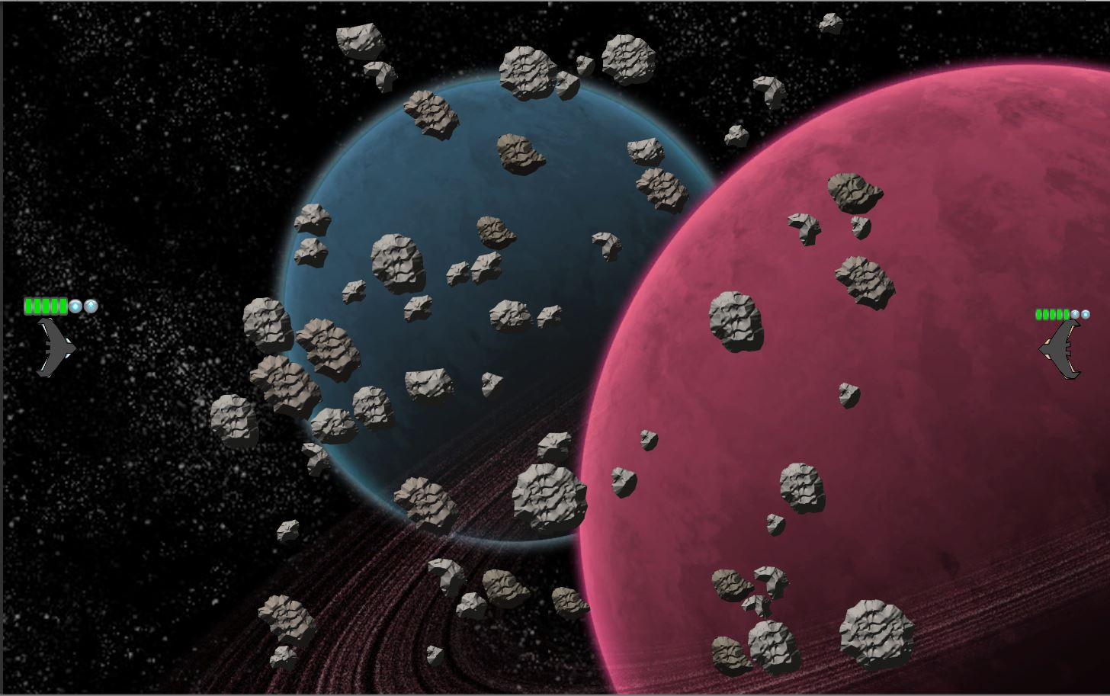

Figure : Same UI layout but different in size, is the right or left better?

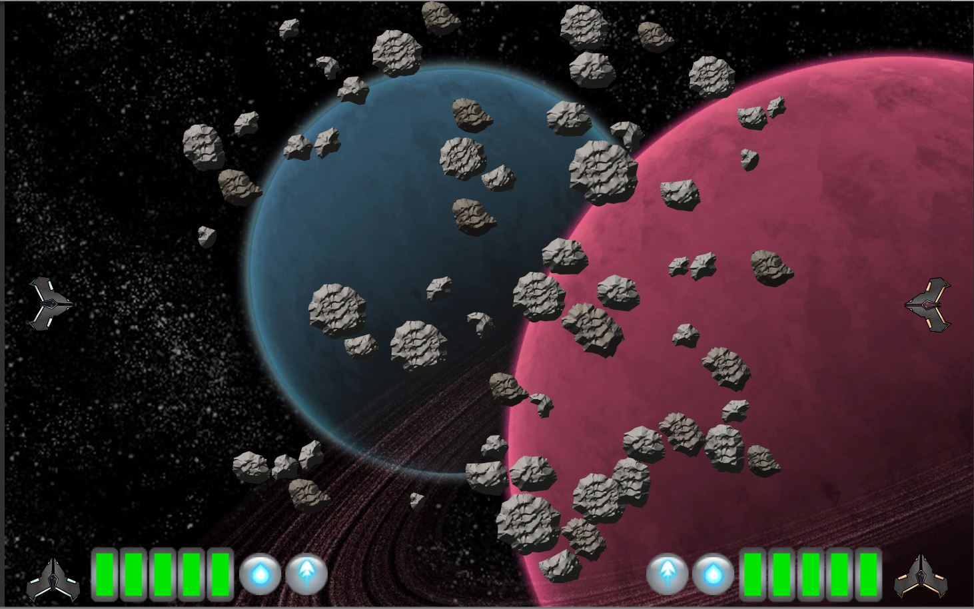

I feel that the second image is clearer but the first flows much nicer with the gameplay.

I prefer the first. They should both be the same size as the one on the left.

**If there is any missing information, what is it?**

When the blackholes will appear.

**Please give a short explanation of any bugs you have encountered**

Rocket got stuck in the corner replaying the explosion animation.

Ships got stuck together.